Notification of Food for Particular Nutritional Uses | 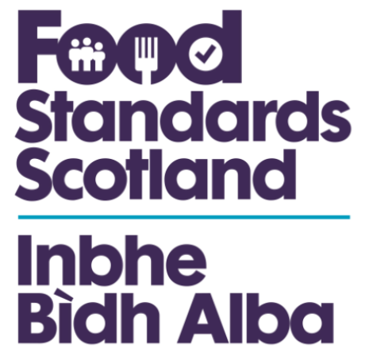

CONTACT DETAILS |  | For FSS Use Only
Food Standards Scotland  Parnut Food Notification  Pilgrim House  Old Ford Road  Aberdeen  AB11 5RL  Tel: 01224 285100  E-mail: enquiries@fss.scot |  | Date notification received
 |  | Date confirmation sent to manufacturer / importer
Date letter sent to
Local Authority

IMPORTANT NOTES
- Notification of marketing of certain foods for particular nutritional uses (PNU foods) is a statutory requirement under the Notification of Marketing of Food for Particular Nutritional Uses (England) Regulations 2007 (SI 2007 No.181), Notification of Marketing of Food for Particular Nutritional Uses (Scotland) Regulations 2007 (Scottish Statutory Instrument 2007 No.37), Notification of Marketing of Food for Particular Nutritional Uses Regulations (Northern Ireland) 2007 (Statutory Rules of Northern Ireland 2007 No.60) and the Notification of Marketing of Food for Particular Nutritional Uses (Wales) Regulations 2007 (SI No. 1040 (W.100))
- These Regulations implement Articles 11 and 14 of Council Directive 2009/39/EC on foodstuffs intended for particular nutritional uses.
- Notification is required when a PNU food is first placed on the market in the UK.
- The term ‘PNU food’ is defined in the Regulations referred to above. Copies of this legislation can be obtained from:
- The Office of Public Sector Information
Tel No: 0870 600 5522
Fax No: 0870 600 5533
Website: www.opsi.gov.uk
- This form may be used as a means of giving the necessary notification to Food Standards Scotland
The duty to notify falls on:
- The manufacturer if the product is manufactured in the European Union; OR
- The importer if the product is manufactured outside the European Union and imported into the UK.
Receipt of your form will be acknowledged.
It is an offence without reasonable excuse to sell a PNU food in the UK if it has not been so notified.
If necessary, Food Standards Scotland may require further information about the product’s compliance with the legislation.
- A separate form should be completed for each product. A copy of the product label must accompany each form.
- If you have any queries about the completion of this form, please contact Food Standards Scotland at the address given at the top of this page.

■ Manufacturer/Importer details
It would be helpful if you could provide below your manufacturer/importer details.
Are you the:  manufacturer OR  importer Tick ONE box only

Company name
Address (in full)
Postcode

Contact name
Telephone No. (including national dialling code)
Fax No. (including national dialling code)
E-mail

If imported, in which country is the product manufactured?
Has this product been notified as a PNU food in other EU Member States? YES NO
If YES, please provide details of the recipient of the first notification in the European Union.

■ Product details
Product name

Product
description

Date this product is being put on the market in the UK
■ Home Authority Details
It would be helpful if you could provide your Home Authority details below.

Name
Address (in full)
Postcode

Contact name (if known)
Telephone No. (including national dialling code)
Fax No. (including national dialling code)
E-mail

A model of the product label should be sent with this form to Food Standards Scotland at the
address given on the front page. Please tick this box to confirm you have done so

Signature |  | Date

Name in BLOCK letters

